Prediabetes Clinical Trial
This report evaluates the effectiveness of three treatments for people with prediabetes to reduce progression to full diabetes: metformin (Met), rosiglitazone (Rosi), and lifestyle adjustments involving diet and exercise. The analysis is based on a randomized clinical trial with 699 participants, where success means avoiding progression to full diabetes. First, we calculated the average success rate for each treatment. Then, we used 10,000 bootstrap resamples within each treatment group and created KDE and ECDF plots to examine the distributions of success rates and the differences between Met vs Rosi, Met vs Lifestyle, and Rosi vs Lifestyle. Finally, we calculated 90%, 95%, and 99% bootstrap confidence intervals to assess whether the differences between treatments were statistically significant.
Table 1. Treatment Outcomes and Success Rates
Treatment | Successes | Failures | Participants | Success Rate | Rank
Rosi | 143 | 90 | 233 | 61.4% | 1
Lifestyle | 125 | 109 | 234 | 53.4% | 2
Met | 112 | 120 | 232 | 48.3% | 3
Total | 380 | 319 | 699 | — | —

Rosi had the highest observed success rate at 61.4%, followed by Lifestyle at 53.4% and Met at 48.3%. The bootstrap KDE plots show roughly bell-shaped distributions centered around these rates. The Rosi distribution is shifted to the right, indicating generally higher estimated success rates, while Met is shifted to the left. The ECDF plots show a similar pattern. However, the distributions overlap, especially between Met and Lifestyle, indicating uncertainty about the differences in effectiveness.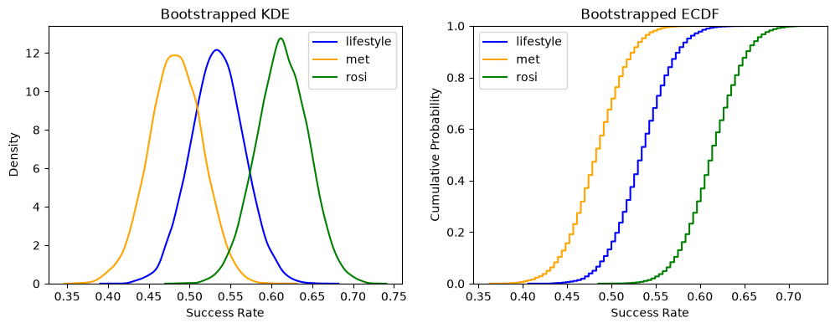Figure 1. Bootstrap KDE and ECDF plots of treatment success rates
Table 2. Treatment Differences and Bootstrap Confidence Intervals
Treatment Comparison | Difference | 90% CI | 95% CI | 99% CI
Met VS Rosi | −13.1 pp | [−0.204, −0.054] | [−0.221, −0.041] | [−0.247, −0.011]
Met VS Lifestyle | −5.1 pp | [−0.128, 0.026] | [−0.142, 0.039] | [−0.171, 0.064]
Rosi VS Lifestyle | +7.9 pp | [0.003, 0.153] | [−0.010, 0.169] | [−0.036, 0.195]
The bootstrap KDE and ECDF plots show the differences in success rates between the three treatments. Met has a lower success rate than Rosi by about 13.1 percentage points and Lifestyle by about 5.1 percentage points, while Rosi has a higher success rate than Lifestyle by about 7.9 percentage points. The Met vs Rosi distribution is mostly below zero, suggesting that Rosi performs better. However, the other two comparisons show more uncertainty because their distributions include both positive and negative values. The confidence intervals show that Rosi performs significantly better than Met at the 90%, 95%, and 99% confidence levels because all intervals exclude zero. For Met vs Lifestyle, all intervals include zero, showing no statistically significant difference. For Rosi vs Lifestyle, only the 90% interval excludes zero, meaning the evidence is weaker. Overall, Rosi appears to be the most effective treatment, but its advantage over Lifestyle is less certain.
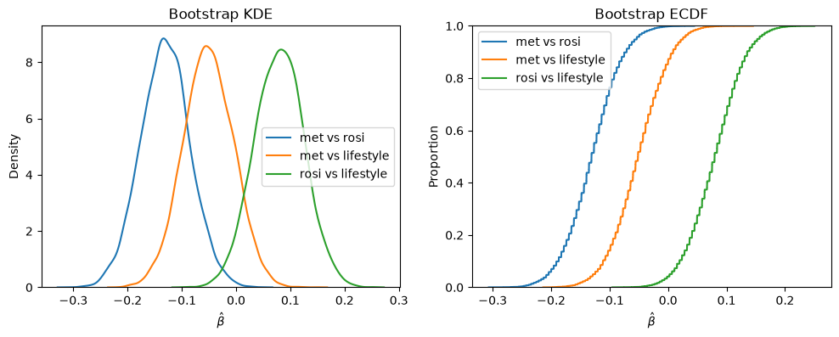Figure 2. KDE and ECDF Plots of Differences Between Treatments
Overall, Rosi appears to be the strongest treatment to consider adopting because it has the highest observed success rate (61.4%) and shows a statistically significant advantage over Met. Lifestyle is also a reasonable option, with a success rate of 53.4%, but there is not enough evidence at the 5% significance level to conclude that it performs differently from Rosi or Met. Met has the lowest success rate (48.3%) and performs significantly worse than Rosi, making it a less favorable choice based on effectiveness alone. However, a lack of statistical significance does not mean that two treatments are equally effective. Although Rosi shows the best results, more research with a larger sample size could help us better understand the differences between the three treatments. Other factors, such as treatment costs and safety, may also be considered before making a final decision.

